Modeling Coupled Processes for Engineering Applications (CIE4365-16)

Assignment 1 Report

Water balance of the Wieringermeer Landfill

Group 8

Yiman Liu (5456703)

Yuwei Huang (5555566)

Yukun Xie (5594448)

Mingkai Wei (5601150)

Civil Engineering, Environmental Engineering

Delft University of Technology, The Netherlands

**Abstract**: This report develops a conceptual model for the Wieringermeer landfill site, located in the Netherlands, and analyses the yield with its percolation rate fluid. The model was programmed in a Python environment. In this model we simulate the capacity of the landfill drainage system to produce leachate by calculating the storage capacity of the landfill cover and waste body, taking into account the possible effects of rainfall and evaporation from runoff. The errors were analysed and studied with reference to relevant studies. Based on the results of the developed model it can be seen that there is a safe link between water storage and drainage. In addition, the hydraulic conductivity and the proportion of leachate entering the drainage system as well as waste objects can have a significant impact on the leachate in the drainage system.

**Keywords**: Wieringermeer landfill, storage, leachate production, modelling

# Introduction

This report is about the development of a conceptual model at the Wieringermeer landfill site in the Netherlands. the KNMI weather station is located in Medemblik, only 10 km from the landfill site we want to model. We have also obtained specific data on the leachate generation rates in the cover and storage layers. To build the model we used the material balance of water as a basis, and the experiment will provide data obtained from the KNMI weather station about rainfall, temperature and evaporation, on which the model is built. The objective of this model is to simulate the leachate from the drainage system and to compare it with the measured data. From this, we can make an evaluation of the landfill design - which factors will have a greater impact on the landfill plant (which will become a key consideration in the actual design operation). Finally, we also aim to calculate the storage capacity of the cover and waste objects based on transport over time. In general, Wieringermeer landfills consist of three layers. They are the cover layer, the waste body layer and the drainage system. In the cover layer, rainfall enters and leachate and evapotranspiration come out. Part of the leachate goes into the waste body and the other part goes directly into the drainage system. In the waste body it no longer has an evapotranspiration effect. The only way out is through leaching to the drainage system.

# Method

## 2.1 Theoretical calculation

The calculation method used in this report was proposed by (Benettin et al.,2015). The idea is to consider the landfill system as a three-layer system consisting of a cover layer, a waste body and a drainage system. The cover layer has a certain porosity that allows for rainwater permeability and transpiration of plants, so the leachate products are also considered for these factors. Below the cover layer is the waste body, which has a certain porosity, which allows water to infiltrate from the cover layer into the drainage system at the bottom of the landfill, as water may go beyond the waste layer and directly into the drainage system. In addition, the pumps maintain a constant water level, so the water balance can be analysed on this basis. In terms of water balance, the calculation of the rate of change of water storage for these three layers has been shown in equations 1 to 3:

$\frac{dS_{cl}}{dt}=J\left(t\right)- E\left(t\right)- (L_{cd}\left(t\right)+L_{cw}\left(t\right))$ (1)

$\frac{dS_{wb}}{dt}=L_{cw}\left(t\right)-L_{wd}\left(t\right)$ (2)

$\frac{dSd}{dt}=L_{cd}\left(t\right)+L_{dw}\left(t\right))-Q_{dr}(t)$ (3)

Here Scl is the water storage of cover layer in meters; Swb is the water storage of the waste body system in meters; J(t) is the rainfall rate in m/day; E(t) is the evaporation rate in m/day; Lcd (t) is the leaching rate from cover layer to drainage system in m/day; Lcw (t) is the leaching rate from cover layer to waste body in m/day; Lwd (t) is the leaching rate from the waste body to the drainage system in m/day; Qdr (t) is the leachate production rate of the drainage system in m3/(m2 day).

In order to reduce the unknowns in the equations, the leaching flow from the cover layer to both drainage and waste body system could be seen as a whole and refer as Lcl (t). The sub-flow Lcd (t) can be referred to as the fraction of β(t) times the total leaching flow Lcl (t). Then the equations can be rewritten as Equation 4 to 6:

$\frac{dS_{cl}}{dt}=J\left(t\right)-L_{cl}\left(t\right)-E(t)$ (4)

$\frac{dSwb}{dt}=(1-β\left(t\right))L_{cl}\left(t\right)-L_{wd}\left(t\right)$ (5)

$\frac{dSdr}{dt}=β\left(t\right)L_{cl}\left(t\right)+L_{wd}\left(t\right)-Qdr\left(t\right)= 0$ (6)

β(t) is a term that allows a certain fraction of water leaching from the cover layer to the drainage system in m/day;

Lcl(t) is the leaching rate from cover layer in meters.

From meteorological datasets, the rates of rainfall J(t) could be directly found. Besides, the evapotranspiration rate could be calculated with the following equation.

$E\left(t\right)=pEV\left(t\right)*C_{f}*fred$ (7)

Cf is the crop factor, and fred is the reduction factor that contributes to evapotranspiration reduction under dry soil conditions. And the relationship between water storage and evapotranspiration of the cover layer could be calculated by using Equation 8.

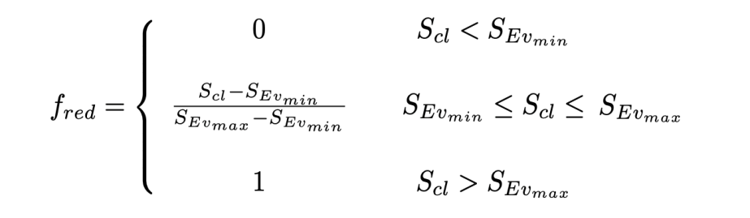 (8)

Moreover, non-linear storage-discharge models could be applied to calculate the leaching flows by using the following equations:

$L_{cl}\text{(t) = }{\text{α}}_{cl}\text{*}{\text{(}\frac{{\text{S}}_{cl}-{\text{S}}_{clmin}}{{\text{S}}_{clmax}-{\text{S}}_{clmin}})}^{b_{cl}}$ (9)

$L_{wb}\text{(t) = }{\text{α}}_{wb}\text{*}{\text{(}\frac{{\text{S}}_{wb}-{\text{S}}_{wbmin}}{{\text{S}}_{wbmax}-{\text{S}}_{wbmin}})}^{b_{wb}}$ (10)

Where 𝛼cl and 𝛼wb are the saturated hydraulic conductivity of the cover layer and waste body respectively in m/day; Bcl and bwb are dimensionless empirical parameters; Sclmin is the minimum water storage in the cover layer in meters; Sclmax is the maximum water storage in the cover layer in meters; Swbmin is the minimum water storage in the waste body layer in meters; Swbmax is the maximum water storage in the waste body layer in meters.

In this case, both Sclmin and Swbmin are supposed to be fixed at 0.5m. The parameters Sclmax and Swbmax, could be calculated by multiplying the porosity of the corresponding layer with the layer height. The height of the cover layer is 1.5 m, and the waste body is 12m.

## 2.2 Python modelling approach

In order to investigate the method of fitting the data when calculating the storage of coverings and waste bodies, it is first necessary to specify the method of fitting the data. We have found four methods to solve this problem. They are based on ODEINT, Euler's method, Runge-Kutta fourth order, and the EULER prediction corrector.

After analysing and comparing these four methods we chose to use the first method, ODEINT, to fit the data as we believe it is based on the fact that python has a built-in solver to solve the problem, and as we do not need to write our own code to approach the integration, the fitting process is more computerised, more accurate, faster to run It is also easier to use. This can be found in the scipy package, which can save a lot of time. For this assignment, we have therefore chosen to use ODEINT to complete the integration.

Once the method has been determined, the initial values will be the main issue to consider. This means that you have to try to understand the functional and physical meaning of the different kinds of parameters is the best way to solve this problem. For some parameters of a constant nature we use a search of the relevant data literature to find reasonable values, such as figuring out the initial values of porosity for different layers. Then distinguishing the parameter gap between the two layers was also mostly solved in this process. Setting the initial values for the runs was also crucial, e.g. at the beginning we set the Y0 too large leading to excessive variation in the fitted curve, which did not fit the measured values well, and only after step-by-step correction did we gradually obtain a more reasonable curve.

# Results and discussion

## 3.1 Result analysis

The model was fitted based on the amount of shallow storage and deep-water storage in the landfill plant. As the leachate monitoring data was measured from 2012-6-14, we have only fitted data after that date to facilitate comparative analysis.

The relationship between rainfall and leachate is shown in Fig. 3. Because of the seasonal nature of local rainfall in the Netherlands, the volume of water stored also varies periodically. The temperate maritime climate allows for abundant rainfall in winter and therefore the maximum storage volume also occurs in winter. However, the data peaks of the two are not perfectly synchronized, due to rain enters the waste body from the cover layer with relatively slow leaching rates

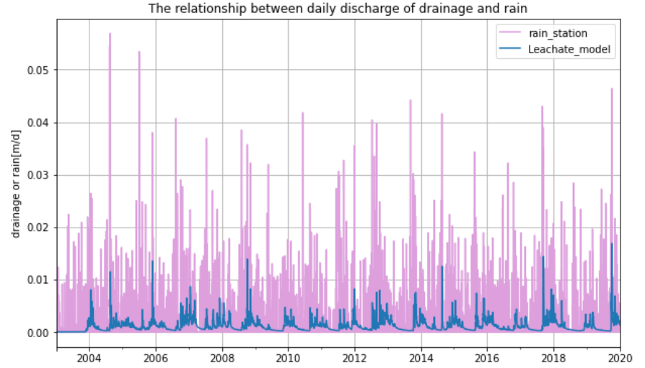

Fig 3. The relationship between the daily discharge of drainage and rain

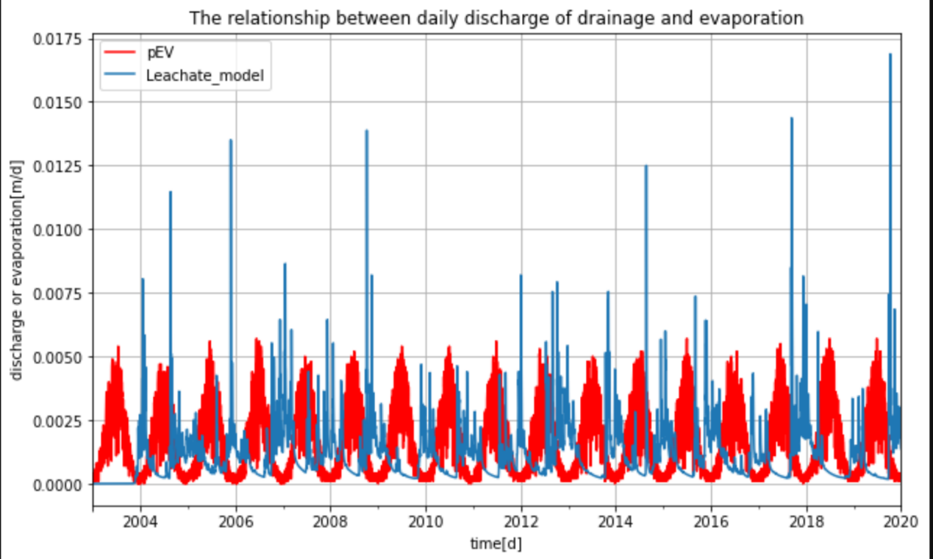The relationship between evaporation and leachate is shown in Fig.4. We can clearly see a clear lag between the peak of leachate and the peak of evaporation. The interannual variation of peak evapotranspiration is not significant, but the seasonal variation of leachate is more significant. Evaporation generally peaks in the summer and is minimal in the winter. Leachate, on the other hand, is maximum in winter and minimum in summer. However, according to the simulation results of the model, the leachate is very small or even smaller than the evaporation in 2010,2011,2017,2019.

Fig 4. The relationship between the daily discharge of drainage and evaporation

Climatic conditions, specifically rainfall and temperature, determines both the quantity and quality of the landfill leachate. High temperature not only leads to high evaporation and consequent high leachate concentrations, but also emit foul odors and even cause fires, this is particularly pronounced in water-scarce areas(Al-Yaqout & Hamoda, 2003). Reduced amount of leachate due to high temperature is observed in San Marcos Landfill(Camba et al., 2014). In Figure 1, the temperature and the quantity of the leachate shows clear inverse trend, which meets the expectation. The quantity of leachate reaches minimum every summer and maximum every winter. There are many burrs in the leachate line, which are caused by a combination of other factors such as will and, humidity, 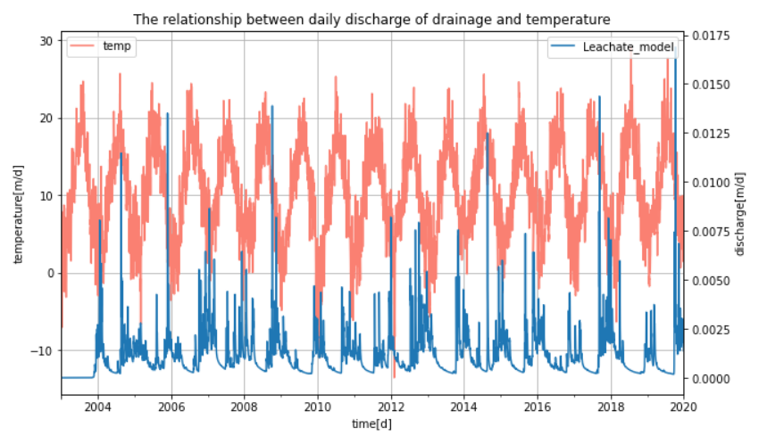compaction, etc.

**Figure 1.** The relationship between daily discharge of drainage and temperature

Al-Yaqout, A. F., & Hamoda, M. F. (2003). Evaluation of landfill leachate in arid climate—a case study. *Environment International, 29*(5), 593-600. doi:<https://doi.org/10.1016/S0160-4120(03)00018-7>

Camba, A., González-García, S., Bala, A., Fullana-i-Palmer, P., Moreira, M. T., & Feijoo, G. (2014). Modeling the leachate flow and aggregated emissions from municipal waste landfills under life cycle thinking in the Oceanic region of the Iberian Peninsula. *Journal of Cleaner Production, 67*, 98-106. doi:<https://doi.org/10.1016/j.jclepro.2013.12.013>